**Primary Target Keyword(s)**

Agriculture Fan, Barn Fans

Agricultural fan, agricultural fans, fans for livestock, livestock fans for sale, large barn fans, outdoor barn fans, barn ceiling fans, barn fans for sale, industrial barn fan, industrial barn fans, industrial ceiling fans for barns

**Body Copy**

# H1: Industrial Agriculture Fans

**Ceiling Fans for Barns and Livestock**

Hunter Industrial Fans are just the tool you’ve been looking for to bring quality air flow into your agriculture space. Our high-volume, low speed (HVLS) fans are designed to bring reliable, steady airflow into any facility no matter what you’ve got growing. With a full product line of HVLS fans that are AMCA certified and come with a Limited Lifetime Warranty, Hunter agricultural fans are ideal for any workspace.

Button: [GET A QUOTE](https://industrialfans.hunterfan.com/pages/get-a-quote) Button: LEARN MORE

## H2: INCREASE COMFORT AND SAVE ON ENERGY COSTS

You know the benefits of keeping your workers, livestock, crops, and produce cool - safer work conditions, reduced heat stress on animals, higher production yield and quality, and much more - but Hunter HVLS fans go beyond that. Thanks to their innovative construction, our industrial agriculture fans are shown to cut energy usage while also reducing the stress and workload put on HVAC systems. Hunter HVLS ceiling fans will help you:

* Increase animal comfort and productivity.
* Mitigate the spread of disease.
* Combat unpleasant odors and pests.
* Achieve a quieter environment than other fan options.
* Create a nearly 10-degree cooling effect.
* Reduce the effects of moisture and fumes.
* Generate year-round energy savings.

**INDUSTRY PAGE IMAGE (1)**

**INDUSTRY PAGE IMAGE (2)**

## H2: INDUSTRIAL CEILING FANS FOR BARNS

Comfort is paramount in the dairy industry. A hot, unpleasant environment leads directly to a decrease in milk production. Luckily, the solution is simple: installing barn ceiling fans! Studies have shown that HLVS ceiling fans for barns reduce heat stress in cattle and use less energy than traditional fans.

[**LEARN MORE**](https://industrialfans.hunterfan.com/blogs/hunter-industrial-blog/industrial-fans-dairy-barn)

**INDUSTRY-LEADING EFFICIENCY - PRODUCTS STAY ON EACH PAGE**

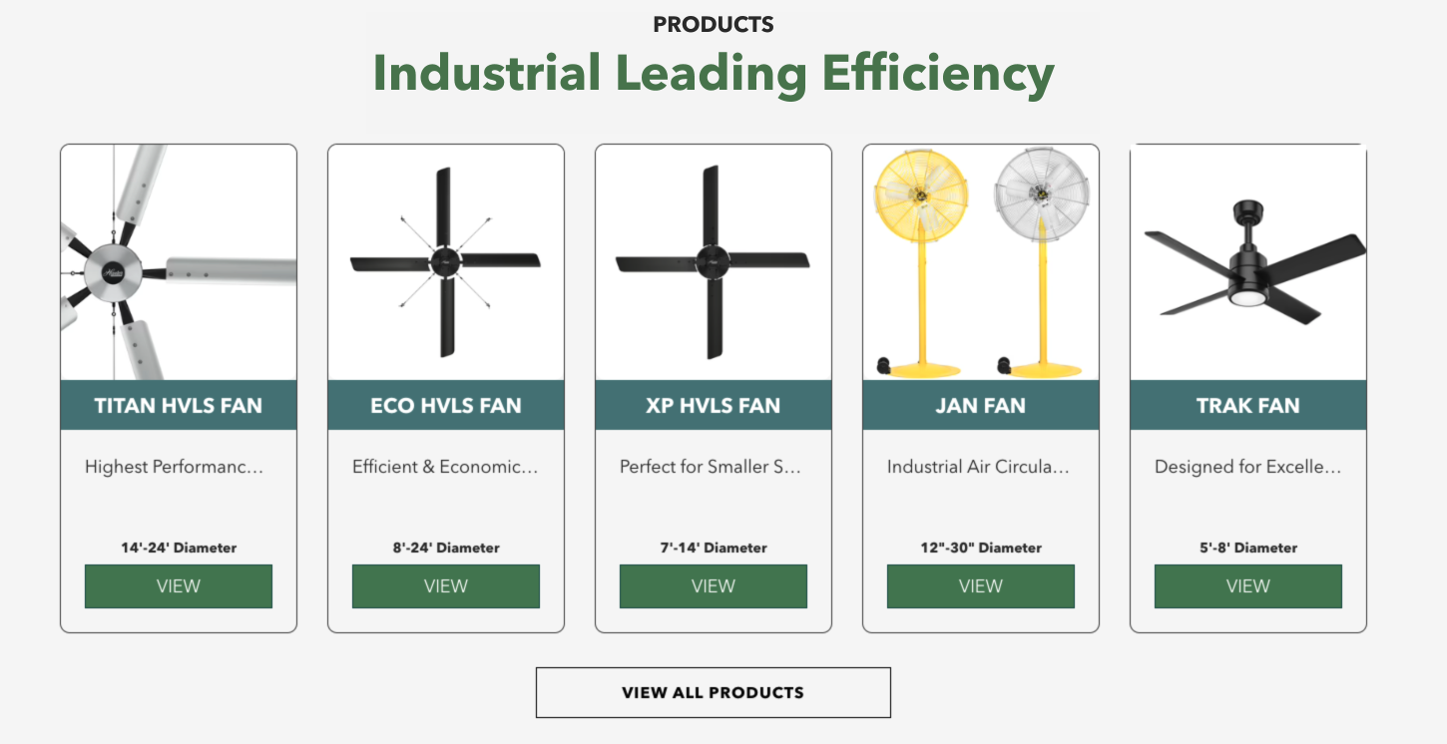

### H3: HEADING - CUSTOMER REVIEW SECTION

“I was impressed by the few parts needed to put Hunter’s fans together, and I’ve been even more pleased by how low maintenance the fans have been since installation. The efficiency and low wattage of Hunter’s fans has been a huge cost saver for me. I hope to be able to work with Hunter for additional barn needs in the future!”

-*Sjouke Plantinga, Pleasant Hills Dairy, Mount Vernon, TX*

## H2: INDUSTRY LEADING WARRANTY

Not only are Hunter industrial ceiling fans engineered for peak performance and reliability, but our HVLS fans are also backed by a Limited Lifetime Warranty! We trust in the quality of our products, that is why our Titan, ECO, and XP HVLS ceiling fans are backed by the best warranty in the industry. Terms apply, learn more [HERE](https://cdn.shopify.com/s/files/1/0555/5434/3079/files/Hunter_Industrial_Warranty_Statement_2022_2.pdf?v=1662491932).

**INDUSTRY PAGE IMAGE (3)**

**INDUSTRY PAGE IMAGE (4)**

#### H2: WORLD CLASS CUSTOMER SERVICE

From order and delivery to installation and cleaning, we are there when you need us! Have a question or concern? Contact us today at 1-844-591-3267.

H3: CHECK OUT OUR SHOWROOM (Video)

Explore the product offerings from Hunter Industrial & Commercial!

Button: SEE ALL VIDEOS

### H3: Frequently Asked Questions

FAQ - Question: How to choose a barn fan?

FAQ - Answer: Many barns have found success by installing HVLS ceiling fans and directional air circulators. Industrial air circulators, like those produced by Jan Fan, provide concentrated airflow directed towards a specific location. HVLS ceiling fans, like the Hunter Titan, ECO, and XP, work to destratify the layers of air and create an all-around cooling effect. It is helpful to consult an expert to ensure the proper fan type and placement. [Contact](https://industrialfans.hunterfan.com/pages/contact-us) the folks at Hunter to learn more.

FAQ - Question: How to hang a fan in a horse barn?

FAQ - Answer: Hunter industrial ceiling fans are engineered for ease of installation. In fact, we are the only company that offers an adjustable downrod, which takes the guesswork out of ordering HVLS fans. Many business owners take advantage of our [installation and maintenance packages](https://industrialfans.hunterfan.com/pages/hunter-service).

FAQ - Question: When is a fan necessary in a barn?

FAQ - Answer: The obvious answer is during the hot summer months. The not-so-obvious answer is that HVLS ceiling fans provide year-round benefits. Dairy barn owners have found that using HVLS fans in the colder months decreases the spread of disease and helps to dissipate harmful odors and fumes.

#### Contact us.

Related Articles

#### H2: KEEP YOUR AGRICULTURAL SPACE SAFE, COMFORTABLE, & PRODUCTIVE

No matter how large or small your facility is, together we can craft a plan to bring air flow and peace of mind to your space. Click below to chat with one of our experts today.

[GET A FREE QUOTE](https://industrialfans.hunterfan.com/pages/get-a-quote)